ASEAN GEOSPATIAL CHALLENGE 2022
Project Write Up

Instructions for Submission
- Participants are to complete all sections using black Calibri font size 12. Incomplete forms will not be accepted.

- Citations should be included where necessary and they are not included in the word count. Participants should fill in their references and other forms of acknowledgment in Section C.

- Participants are to submit this write up in an editable Word Document format.

- Submission filename taxonomy:
AGC22_Country_TeamName (e.g. AGC22_Singapore_GeospatialChallengers)

Judging Criteria

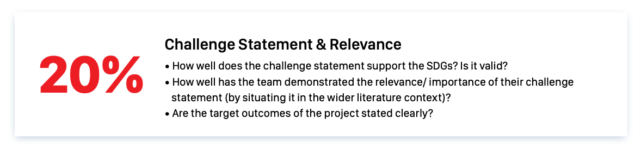
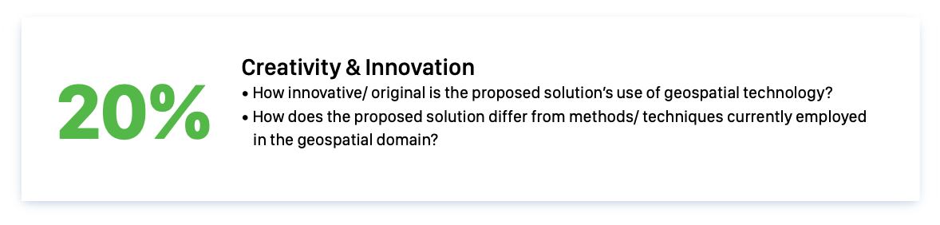
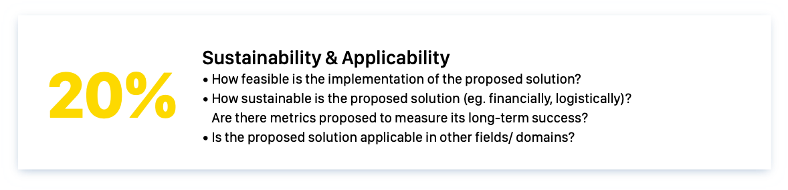
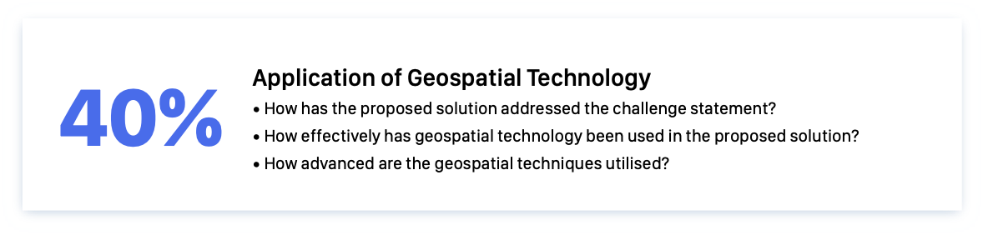
Participants are encouraged to familiarise with the judging criteria. Below are some guiding pointers and they are non-exhaustive.

Section A: Team Composition

Team Name

Participants are to provide their full name as per their relevant identification documents.

Name | Name of Educational Institution | Email Address
(Student Representative)
(Team Member)
(Team Member)
(Team Member)

Section B: Project Details
Project Title
Summary of Project | Explain, in less than 150 words, what the project is about.

Participants are to fill in their word count for each criterion.

Criterion 1: Challenge Statement & Relevance (20%)
Max 600 words Actual count:
Criterion 2: Application of Geospatial Technology (40%)
Max 1000 words Actual count:

Criterion 3: Creativity & Innovation (20%)
Max 600 words Actual count:
Criterion 4: Sustainability & Applicability (20%)
Max 600 words Actual count:

Section C: References
Participants should clearly state their references and other forms of acknowledgment in this section here.

